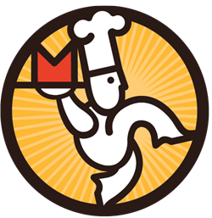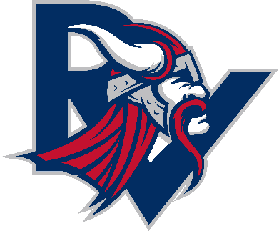**EAST ELEMENTARY**

**CAFÉ**

**Hershey Ice Cream Items**

* **Foam Cups (Sherbet/ Ice Cream) $1.25**
* **Mini Ice Cream Sandwiches $1.25**
* **Ice Cream Bars (Fudge/Scooters/Polar Bars) $1.50**
* **Cones/ Twister Cups/ Ice Cream Sandwich/Juice Rush- $1.75**

